CPE 301: Altera FPGA Tutorial for 5CSEMA5F31C6N

Spring 2019

This tutorial will guide you through the following steps:

1. Creating a new project
2. Adding Source Code
3. Assigning Package Pins to Signals
4. Uploading the Code to the FPGA

# Creating a New Project

1. Open Quartus II from the Start Menu / Desktop

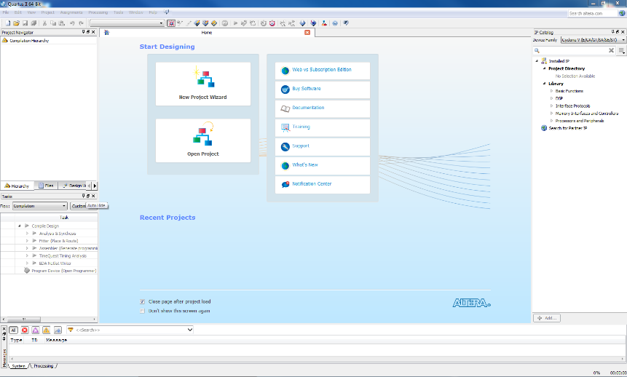

1. File -> New Project Wizard

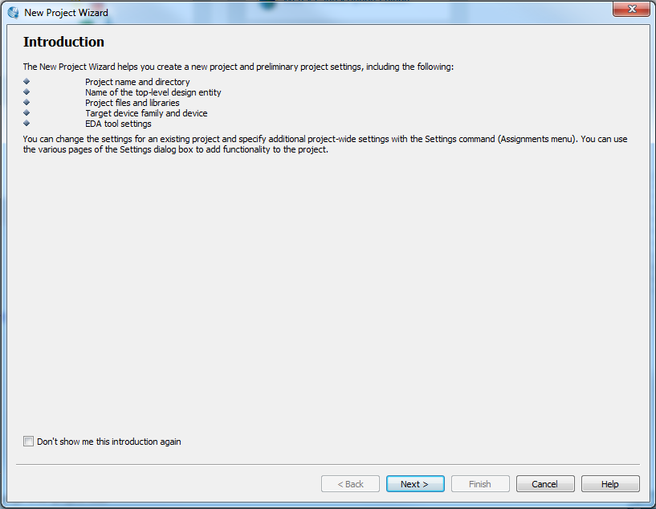

1. Create your own project folder on the Desktop.
   1. Name it something unique.
   2. Make sure it is on the local desktop, not on your cloud drive.
   3. Explicitly place in on the C: drive : (C:\Users\<MY_USERNAME>\Desktop)
2. Choose the folder you created and name the project gate2.

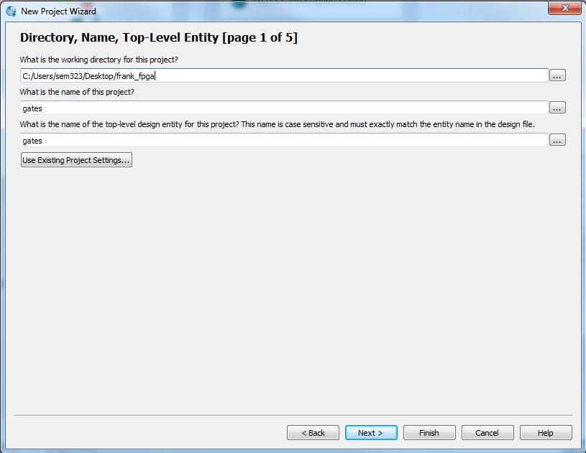

1. Click Next
2. We don’t have any design files to add right now, so click Next

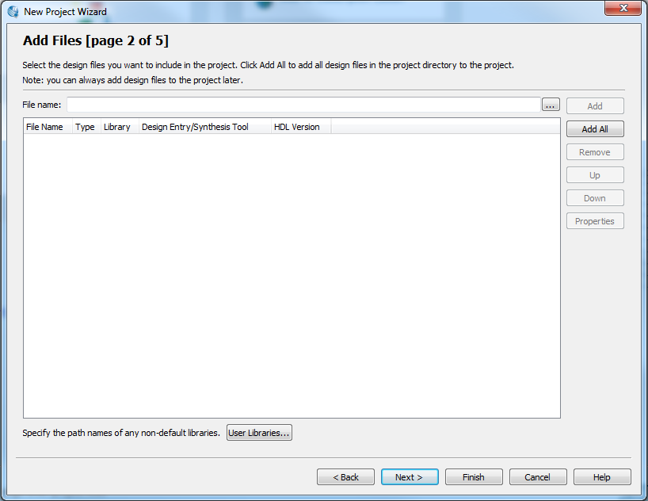

1. Select the correct device:
   1. Family: Cyclone V
   2. Device: 5CSEMA5F31C6N

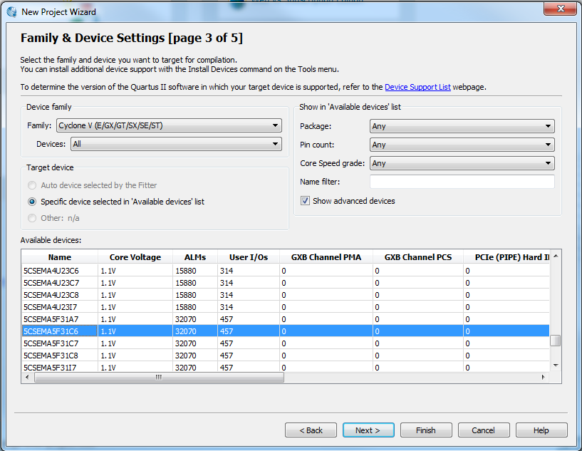

1. Click Next
2. We won’t be using these advanced features, so click next.

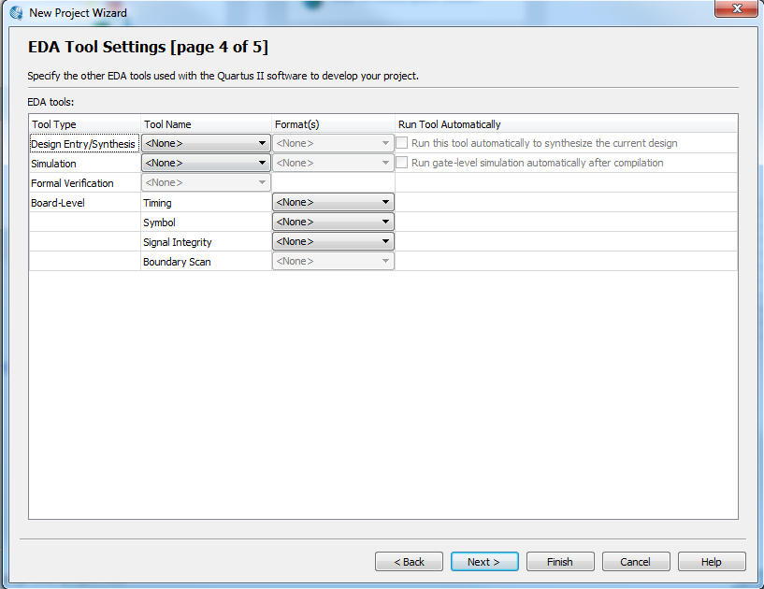

1. Review the project settings, and click finish.

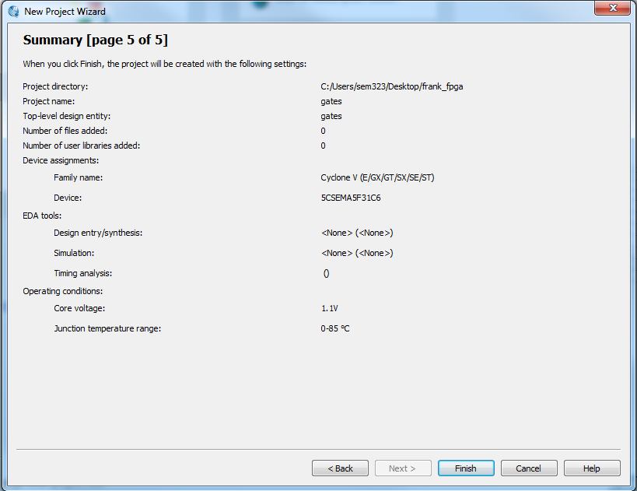

This is the general display of the new project. We’ve completed setting up our new project.

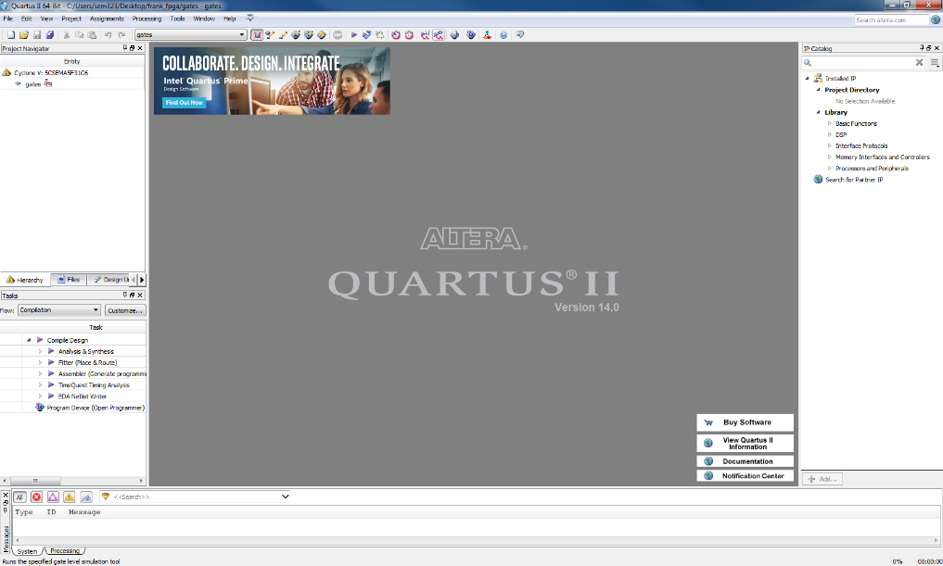

# Adding new source files

1. Let’s add a new source code file to the project: File -> New -> Verilog HDL File

A blank file with the name Verilog1.v appears.

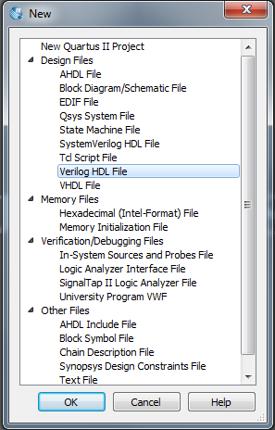

1. Now save it as gate2.v: File -> Save as
2. Copy this example code into the source file:

module gate2 (in_a, in_b, out);

input wire in_a; // declare input variable in_a

input wire in_b; // declare input variable in_a

output wire [5:0] out; // declare out variable out

assign out[5] = in_a&in_b; // AND operation

assign out[4] = ~(in_a&in_b); // NAND operation

assign out[3] = in_a | in_b; // OR operation

assign out[2] = ~(in_a | in_b); // NOR operation

assign out[1] = in_a ^ in_b; // XOR operation

assign out[0] = ~(in_a ^ in_b); // NXOR operation

endmodule

Your screen should then look like this:

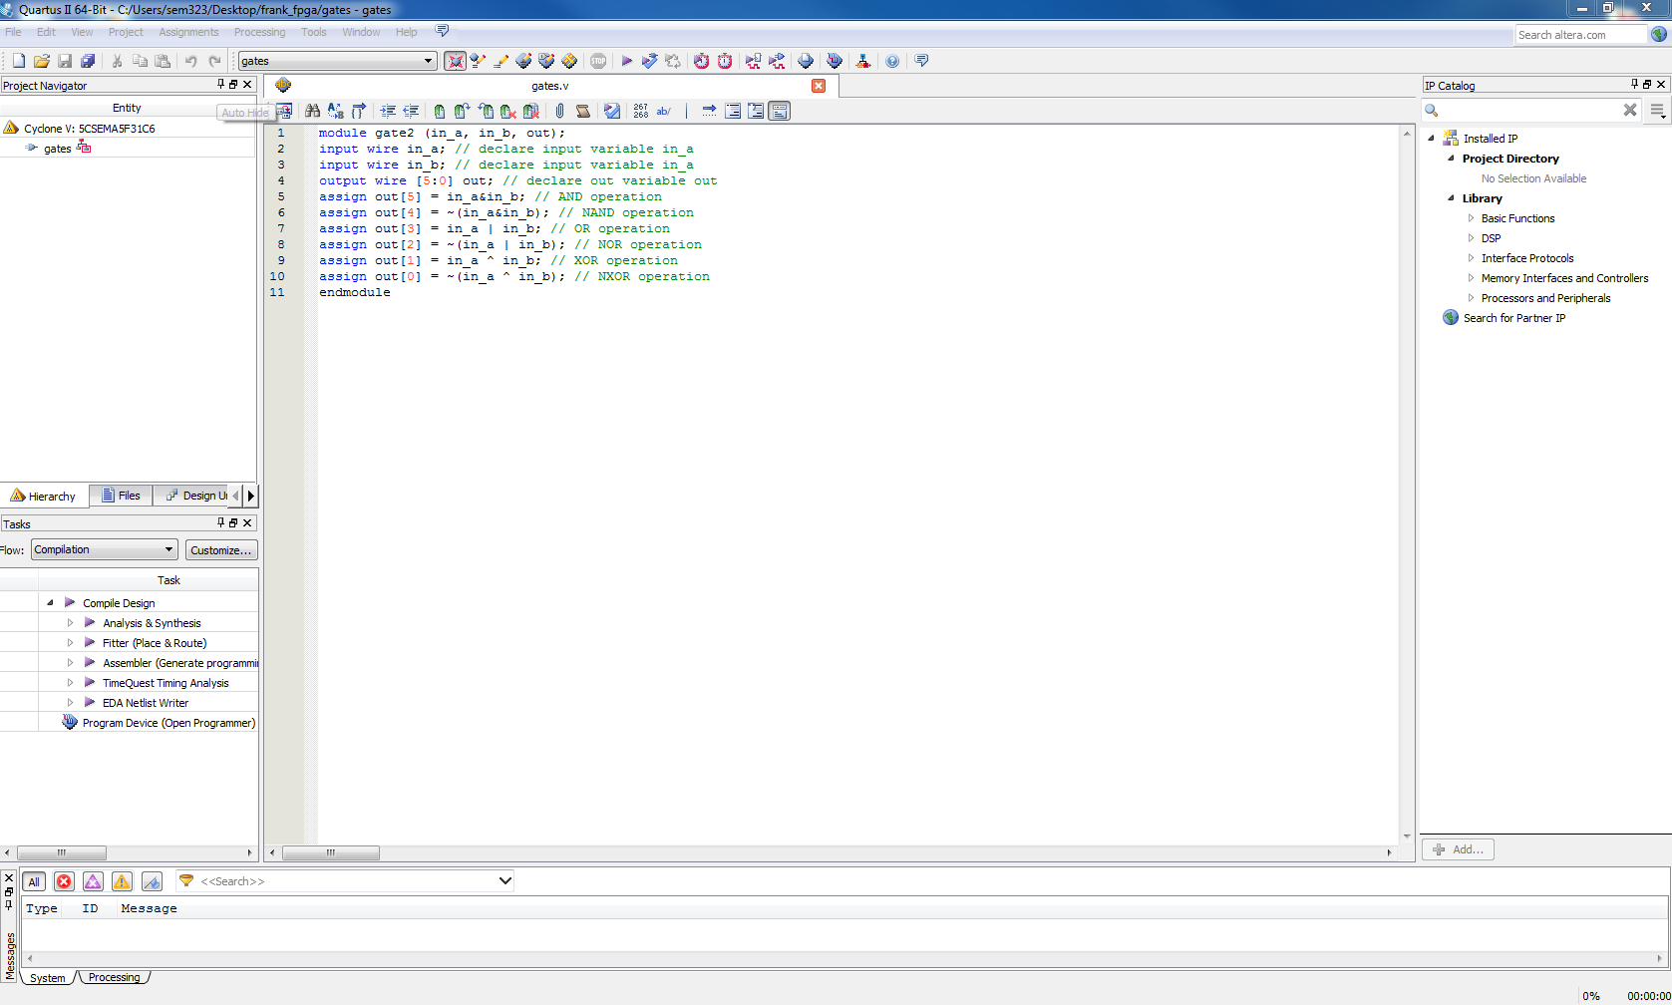

1. Right-click the source file in the file hierarchy and set the file as the top level entity. (You may need to select “Files” in the project navigator)

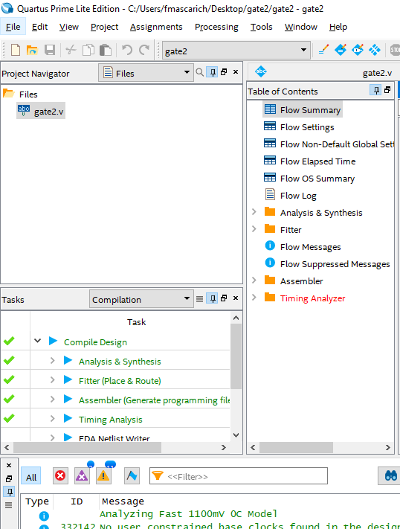

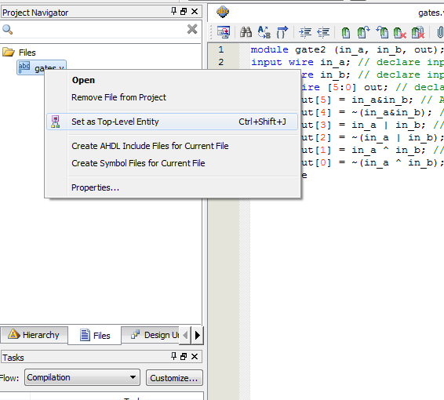

1. Double-check that you selected the correct device:

Tool bar ->Assignments ->Devices..: You should see Cyclone V, 5CSEMAF31C6.

**You can also go to the Boards menu and select the DE1-SoC at the bottom of the list.**

1. Start compiling the code:

Tool Bar -> Processing -> Start Compilation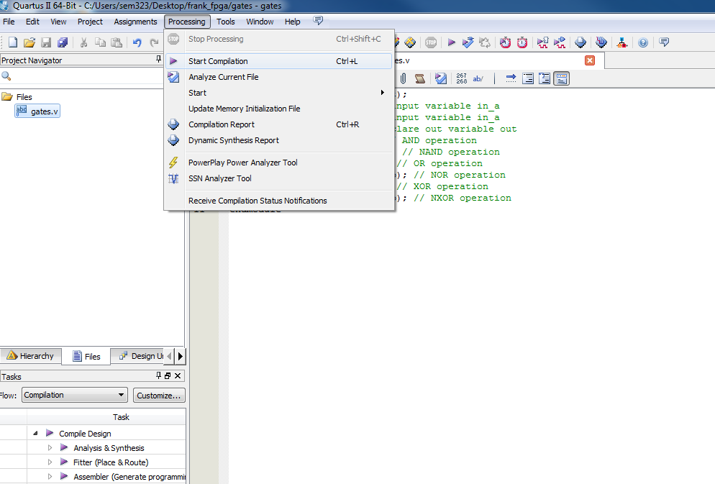

Make sure the module name matches the file name: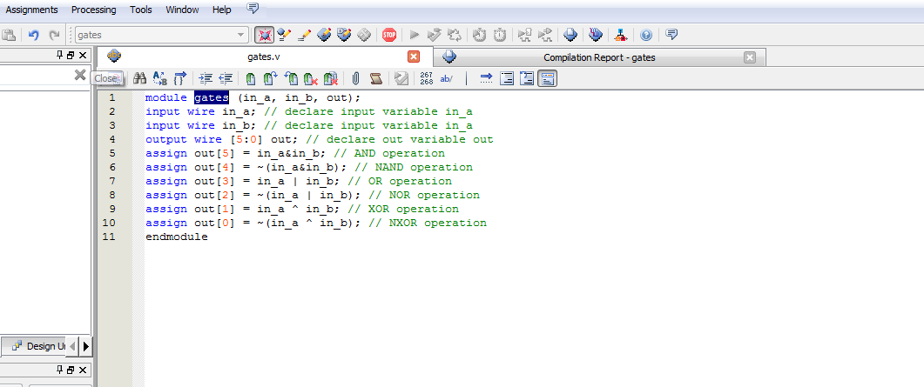

# Assigning Pins to Signals

1. Assign the pins to the signals.

a) Tool bar ->Assignments -> Pins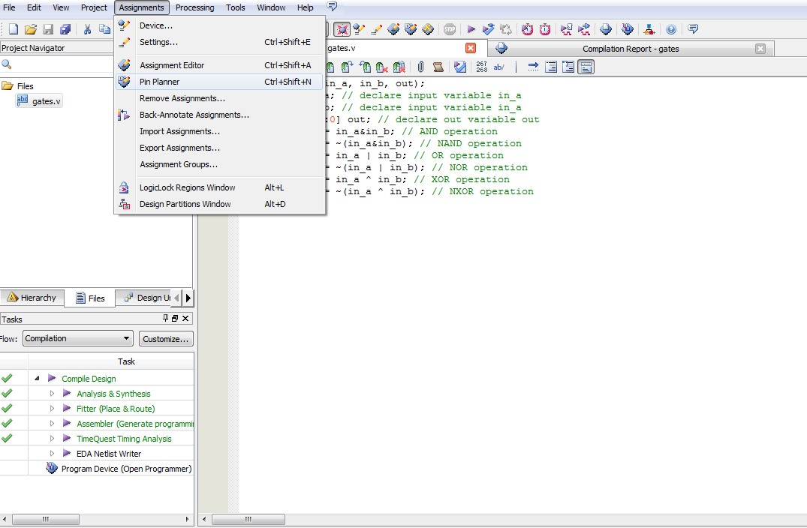

b) a new window,“Pin Planner”, should appear as below:

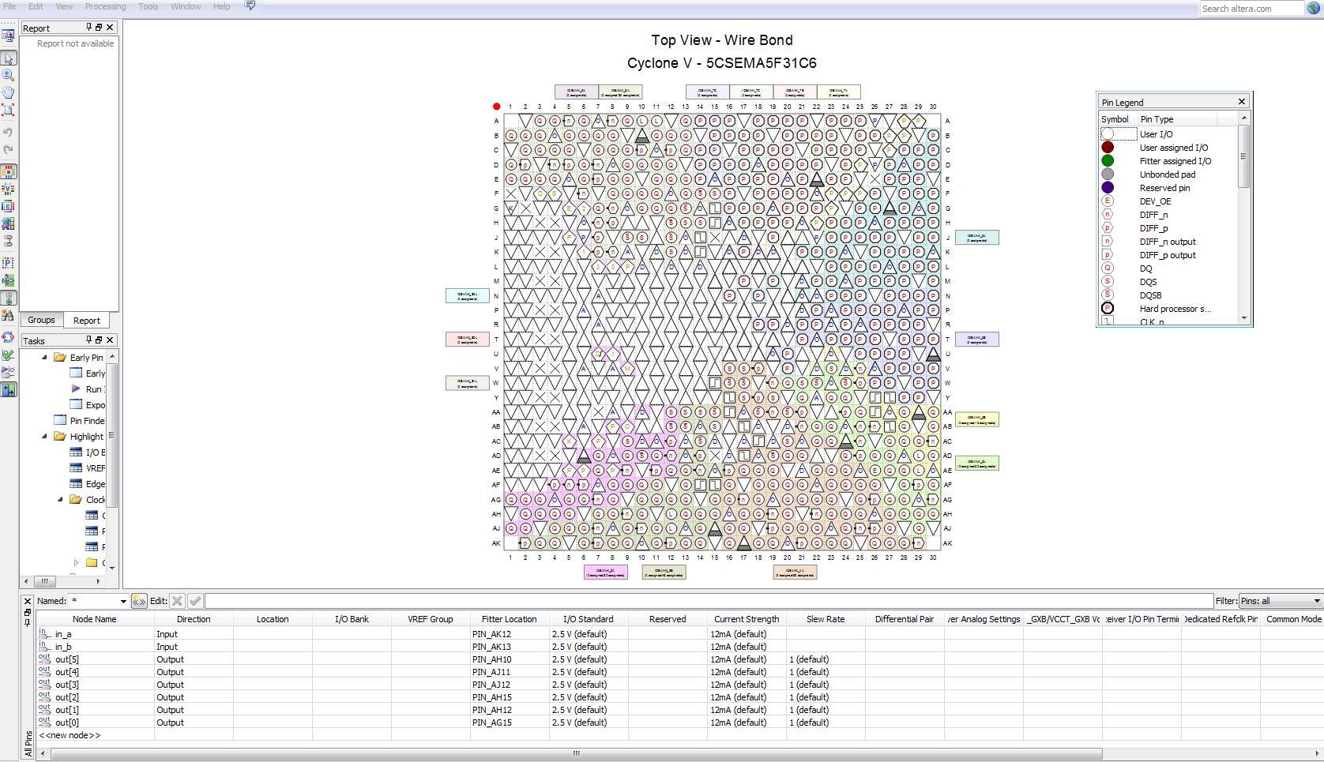

*Note: if you don’t see the bottom window, go to View ->All Pins List from the Pin Planner window.*

*Here are the pin assignments you’ll need as provided by Quartus:*

*LED Pins:*

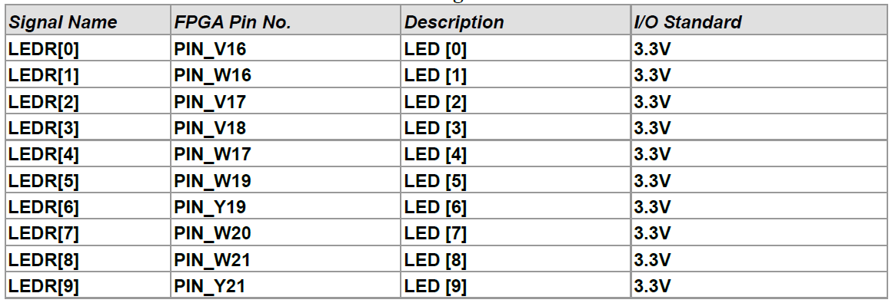

*Slide Switch Pins:*

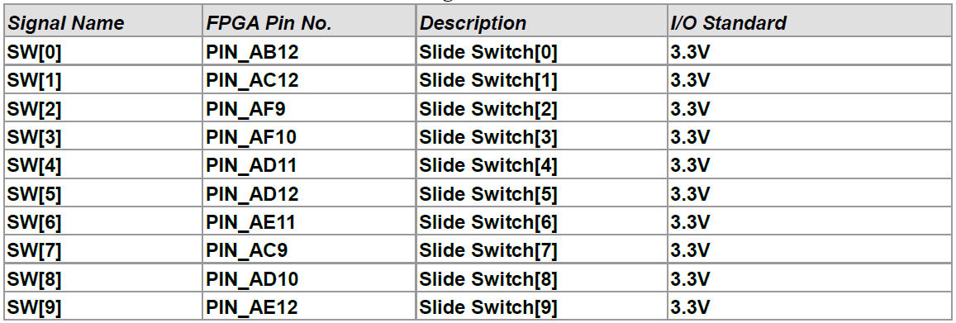

*Push Button Pins:*

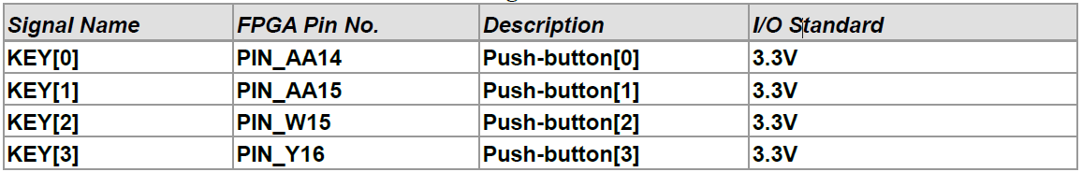

*7 Segment Pins:*

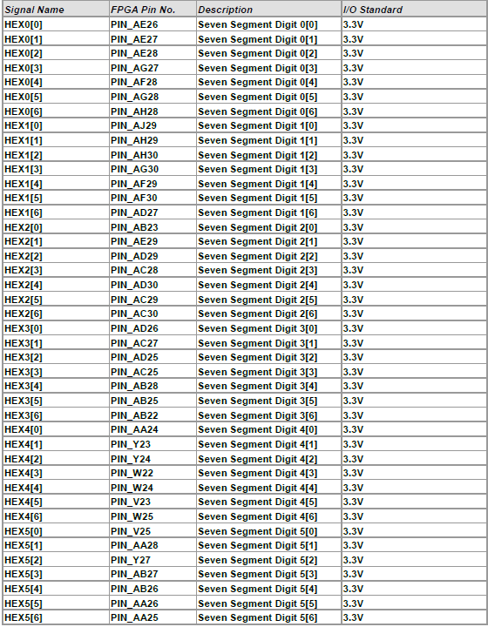

1. Now we will assign the pins as follows:

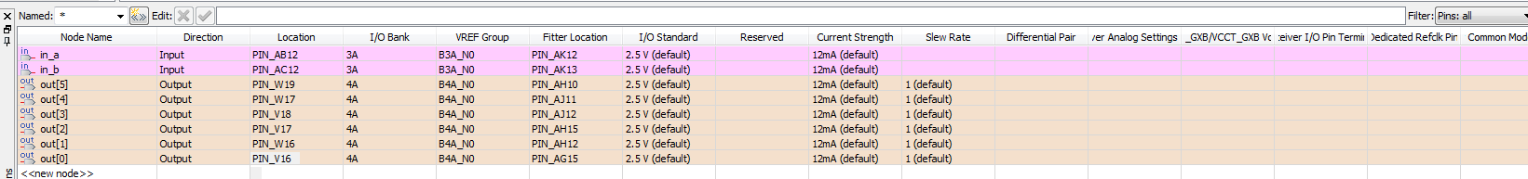

1. Close the Pin Planner window.

# Uploading Code to the Board

1. Compile the code again by going to Processing ->Start Compilation. The Message window should look like this when compilation is successful.

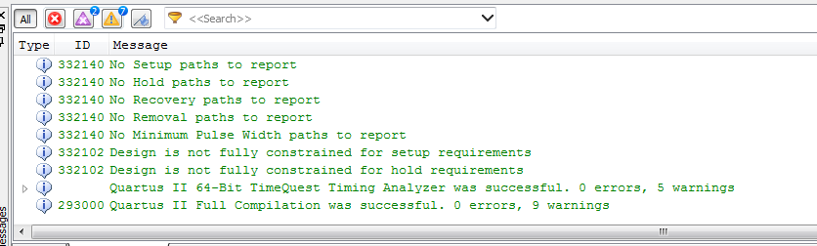

1. Go to Tools ->Programmer, a new window appears: 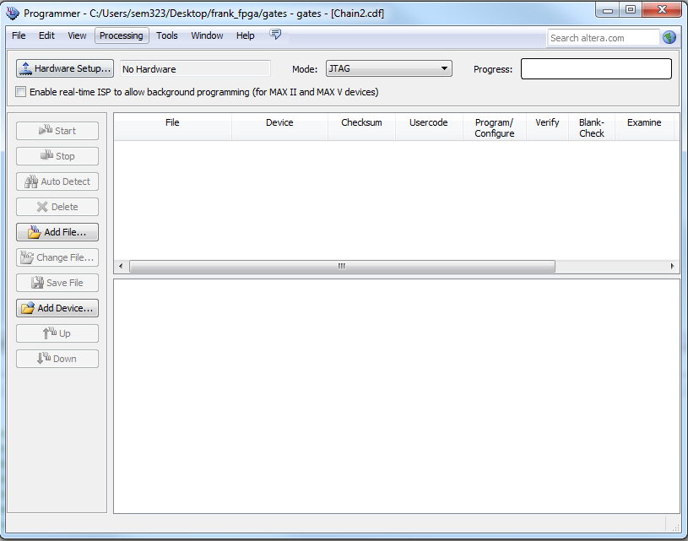
2. Check if the Hardware Setup section is USB-Blaster. If not, install the USB driver as follow:

a. Go to device manager, select Other Devices and select the USB-Blaster -> Update Driver

Software -> Browse my computer for driver software.

b. Point to the folder: C:\altera\91sp2\quartus\drivers\usb-blaster where C:\altera is the

installation folder of Quartus.

c. Click Next -> Done.

d. If the driver is successfully installed, you should be able to select USB-Blaster in

Hardware Setup.

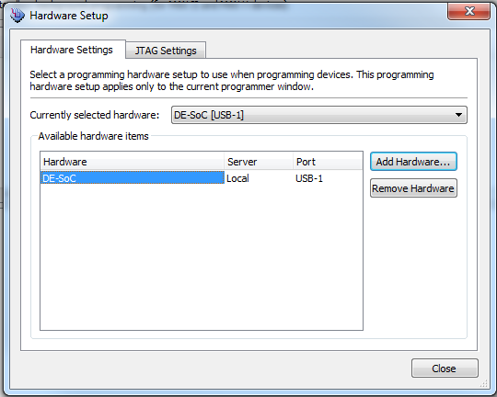

1. Select the Correct Device

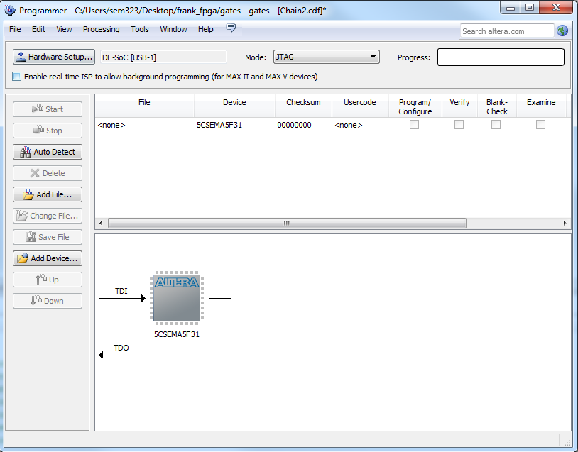

1. Add the programming file, by clicking “Add File”

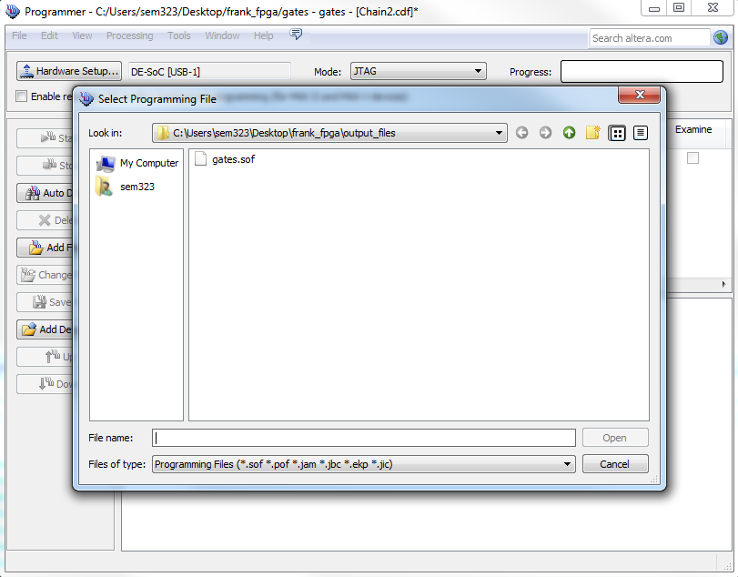

1. Add the “gates.sof” file

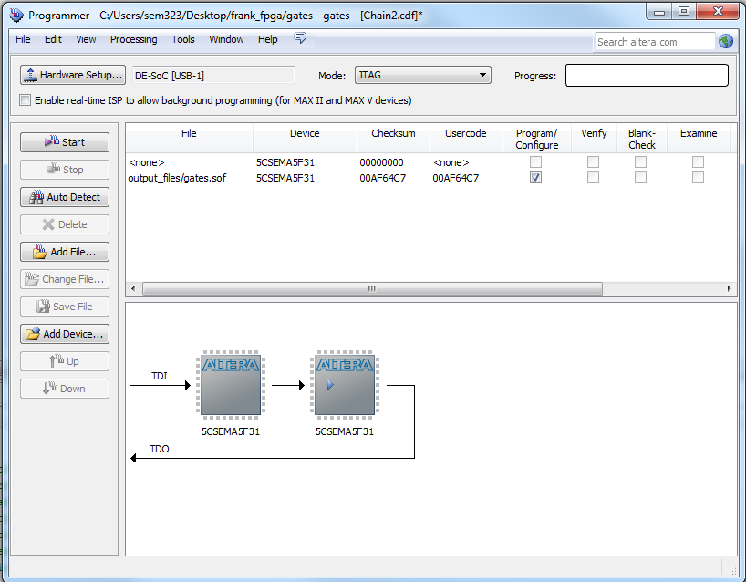

1. Remove any file listings which may have been added by default, they will not have 5CSMA5F31 in the Device column.
2. Click Start

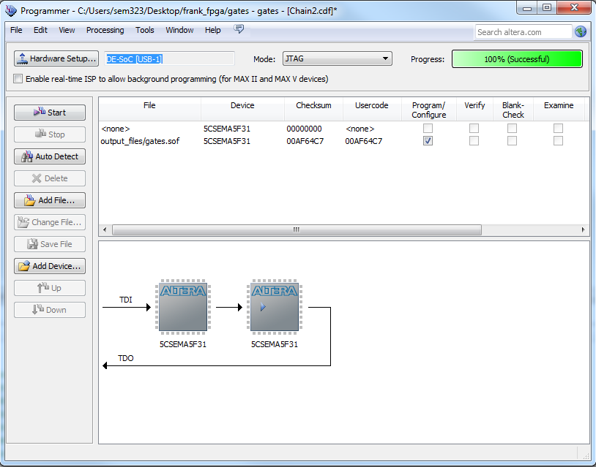

We have programmed the FPGA, verify that the code we programmed is working as expected.